- Section A - Concept Application

S1. What factors should be considered when selecting the CPU, RAM, and storage to ensure good performance and hardware compatibility?

Answer
Since employees will use many applications at the same time, the computer should have good CPU, enough RAM, and fast storage.
1. CPU (Processor):
- A modern Intel Core i5/i7 or AMD Ryzen 5/7 can be selected.
- The CPU should have multiple cores so it can handle programming, browsing, and video meetings together.
- The processor must be compatible with the motherboard socket and chipset.
2. RAM:
- At least 16 GB RAM is a good choice for smooth multitasking.
- The RAM type, such as DDR4 or DDR5, must be supported by the motherboard.
- RAM speed and maximum supported capacity should also be checked.
3. Storage:
- An SSD should be used instead of an HDD for the operating system and applications.
- A 512 GB SSD or higher is suitable for normal office and programming work.
- NVMe SSD can provide faster performance if the motherboard supports it.

- Conclusion:
A good CPU, 16 GB RAM, and SSD storage will allow employees to run multiple applications smoothly. Before purchasing, we should also check that the CPU, RAM, storage, and motherboard are compatible with each other.

S2. Explain how the antivirus software affects CPU, RAM, and storage performance, leading to system slowdowns?

Answer
Antivirus software continuously works in the background to protect the computer. Because of this, it uses some hardware resources.
- CPU: Antivirus uses the CPU to scan files, applications, downloads, and running processes. During a full system scan, CPU usage can increase.
- RAM: Antivirus stays active in memory for real-time protection, so it uses some RAM. If the computer has less RAM, other applications may become slower.
- Storage: Antivirus regularly reads files from the HDD or SSD to check them for viruses. A full scan can create high disk activity.
- When CPU, RAM, and storage are already being used by other applications, antivirus scanning adds extra load and can make the system feel slow.
- Conclusion:
Antivirus is important for security, but it also uses CPU, RAM, and storage resources. The slowdown is more noticeable on computers with low RAM, slower storage, or older processors.

S3. Describe the steps you would follow to troubleshoot the problem if it is caused by driver incompatibility or operating system issues?

Answers
If the USB keyboard and printer work on one computer but not on another, I would follow these steps:
- Check USB connection:
Disconnect the keyboard and printer and connect them again. I would also try a different USB port.
- Check Device Manager:
Open Device Manager in Windows and check whether the keyboard or printer shows any warning sign.
- Update the driver:
Right-click the device and select Update driver to install the latest compatible driver.
- Reinstall the driver:
If updating does not work, uninstall the device driver and restart the computer. Windows may automatically reinstall the correct driver.
- Check OS compatibility:
Make sure the keyboard/printer driver supports the installed version of Windows.
- Update Windows:
Check Windows Update and install available updates because some updates contain device drivers and compatibility fixes.
- Restart and test:
Restart the computer and test the keyboard and printer again.
- Conclusion:
If the devices work on another computer, the devices are probably fine. The problem is more likely related to the driver, USB configuration, or operating system on the affected computer.

S4. Explain how a UPS and surge protector help protect computer hardware and prevent data loss during power cuts and voltage fluctuations?

Answers
A UPS (Uninterruptible Power Supply) and surge protector are useful for protecting computers from power problems.
- UPS during power cuts:
A UPS has a battery that provides temporary power when the main electricity goes off. This gives the user enough time to save their work and safely shut down the computer.
- Prevents data loss:
Without a UPS, a sudden power cut can shut down the computer immediately, which may cause unsaved work to be lost or files to become corrupted.
- Surge protector:
A surge protector protects computer hardware from a sudden increase or spike in voltage.
- Protects hardware:
Voltage spikes can damage components such as the power supply, motherboard, and storage devices. A surge protector helps reduce this risk.
- Conclusion:
A UPS provides temporary backup power, while a surge protector protects against voltage spikes. Using both helps keep the computer hardware and data safer.

S5. Explain how DNS and DHCP work together in this network, and identify which service is most likely misconfigured based on the symptoms described?

Answer
DNS and DHCP are both important network services.
- DHCP (Dynamic Host Configuration Protocol):
DHCP automatically gives devices their IP address, subnet mask, default gateway, and DNS server address when they connect to the network.
- DNS (Domain Name System):
DNS converts a name into an IP address. For example, if an application server has the name server1, DNS helps the computer find its IP address.
- How they work together:
DHCP gives the computer its network settings, including which DNS server to use. The computer can then contact DNS to find devices or servers by name.
- Problem in this scenario:
Employees can reach the internal server using its IP address but not its name, which indicates a DNS problem. The fact that some devices also fail to get a valid IP address indicates there may also be a DHCP configuration problem.
- Conclusion:
Both DNS and DHCP should be checked. DNS is related to the server-name problem, while DHCP is related to devices not receiving valid IP addresses.

S6. Describe the troubleshooting steps you would take to determine whether the firewall rules are blocking legitimate traffic, and how you would resolve the issue?

Answer
After installing the new firewall, employees can use the internet but cannot access the internal application server. I would follow these steps:
- Check connectivity:
Use the ping command to check whether the application server can be reached.
- Check the server:
Make sure the application server is powered on, connected to the network, and using the correct IP address.
- Check firewall rules:
Review the firewall rules to see if any rule is blocking traffic to the internal server.
- Check IP address and port:
Make sure the server's IP address and the required application port are allowed through the firewall.
- Check firewall logs:
Check the firewall logs for blocked connections from employees' computers to the application server.
- Correct the rule:
If legitimate traffic is being blocked, modify or create an allow rule for the required server IP address, protocol, and port.
- Test again:
After changing the firewall rule, test the connection again to confirm that employees can access the server.
- Conclusion:
The firewall should allow required internal traffic while continuing to block unwanted traffic. After correcting the firewall rule, users should be able to access the application server.

- Section B — Practical Application

Task 1: Workstation Assembly

Answer
- Step 1: Prepared the Components
I collected all required components such as motherboard, CPU, RAM, storage, PSU and CPU cooler.
- Step 2: Installed the CPU
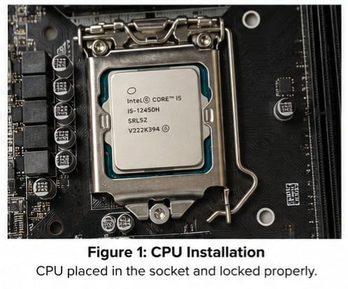
I carefully placed the CPU into the motherboard socket and locked it properly.

- Step 3: Installed the CPU Cooler
I installed the CPU cooler and connected its fan cable to the CPU_FAN header.
- Step 4: Installed the RAM
I aligned the RAM correctly and inserted it into the RAM slot until it locked properly.
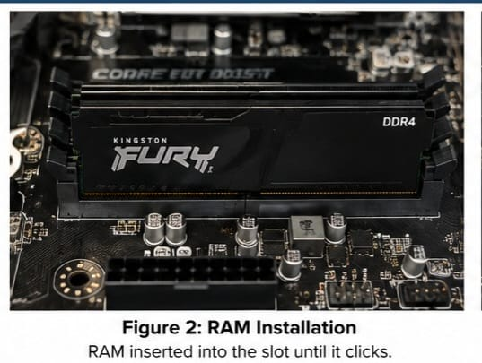

- Step 5: Installed the Storage
I installed the SSD/M.2 storage drive in its correct slot.
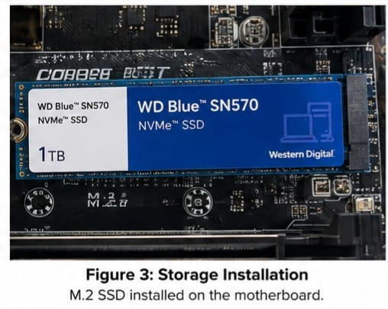
- Step 6: Installed the Motherboard and PSU
I installed the motherboard and power supply inside the computer cabinet.
- Step 7: Connected Internal Cables
I connected the required power, data and front-panel cables properly.
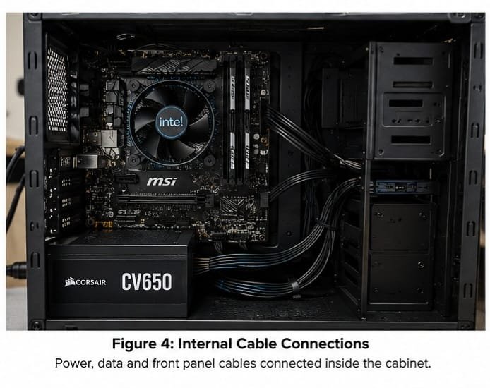
- Step 8: Final Check and POST
After checking all connections, I powered on the computer. The system successfully completed POST and the installed hardware was detected.
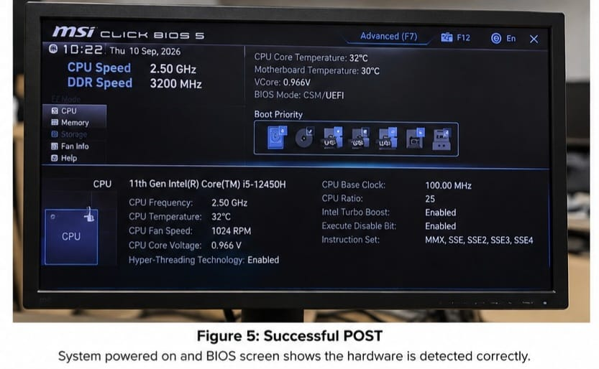
- Conclusion
The workstation was assembled successfully. All components and cables were properly installed, and the computer successfully passed the Power-On Self-Test (POST).

Task 2: RAM Mismatch Troubleshooting

Answer
Troubleshoot and resolve a RAM mismatch error within the BIOS/UEFI settings on a startup office workstation. The assessment requires you to identify the mismatch, determine whether it is caused by speed, timing, or capacity, fix/reseat the RAM, and confirm normal boot afterward.
- Step 1: Opened BIOS/UEFI
I started the computer and entered the BIOS/UEFI setup using the required BIOS key.
- Step 2: Checked RAM Information
I checked the memory information in BIOS/UEFI, including the RAM capacity and speed, to identify the mismatch.
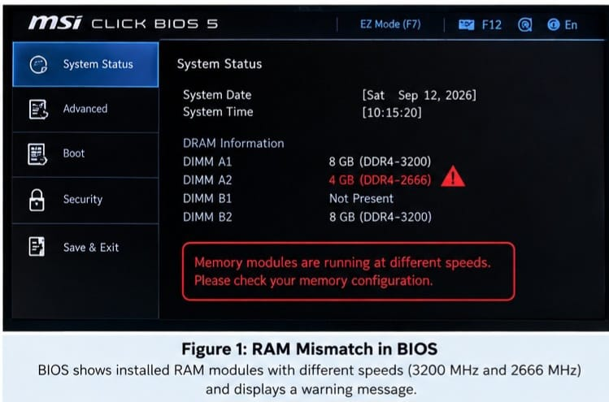
- Step 3: Identified the Problem
I found that the installed RAM modules were not matching correctly in speed, timing, or capacity, which could cause the RAM mismatch error.
- Step 4: Powered Off the Computer
I shut down the computer and disconnected the power cable before touching the RAM.
- Step 5: Reseated the RAM
I removed the RAM modules and inserted them again correctly into the RAM slots. I made sure both sides were properly locked.
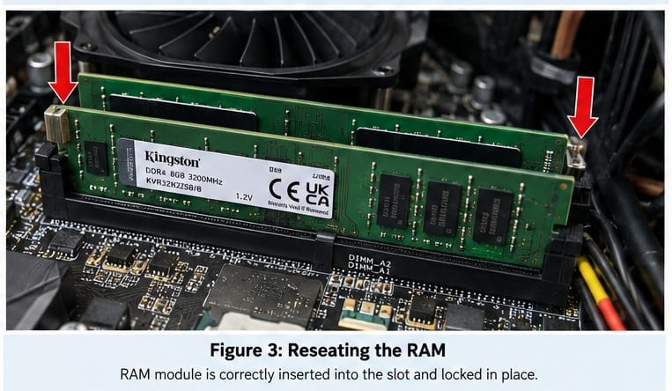
Step 6: Checked BIOS Again
I powered on the computer and opened BIOS/UEFI again. The RAM was now detected correctly with the expected capacity and settings.
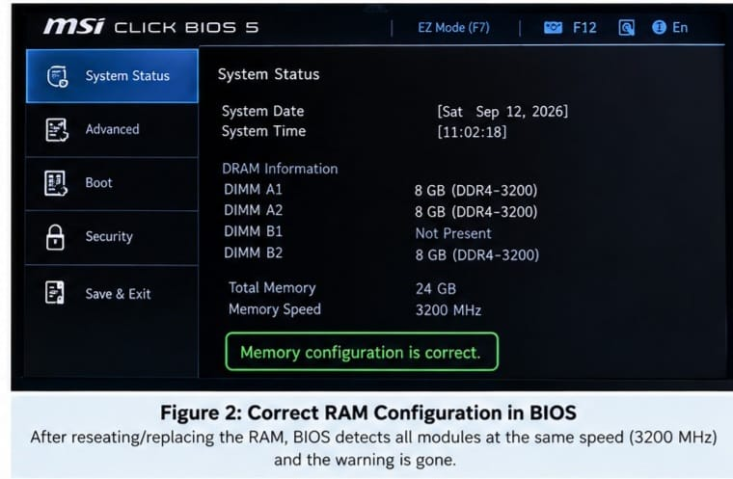
- Step 7: Confirmed Normal Boot
I exited BIOS and allowed the computer to start. The operating system booted normally without a RAM error.
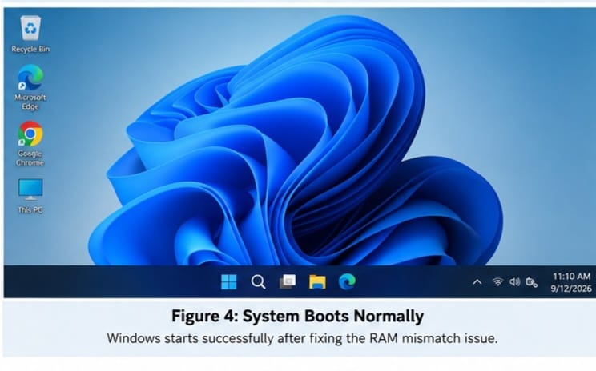
- Conclusion
The RAM mismatch problem was solved by checking the RAM information and correctly reseating/configuring the RAM. After fixing the issue, the system detected the RAM correctly and booted normally.

Task 3: LAN Topology Build

Answer
- Step 1: Open Cisco Packet Tracer
I opened Cisco Packet Tracer and created a new network topology.
- Step 2: Add Devices
I added:
- 1 Switch
- 5 PCs
- 1 Network Printer
- Step 3: Connect the Devices
I connected all 5 PCs and the printer to the switch using Copper Straight-Through cables.
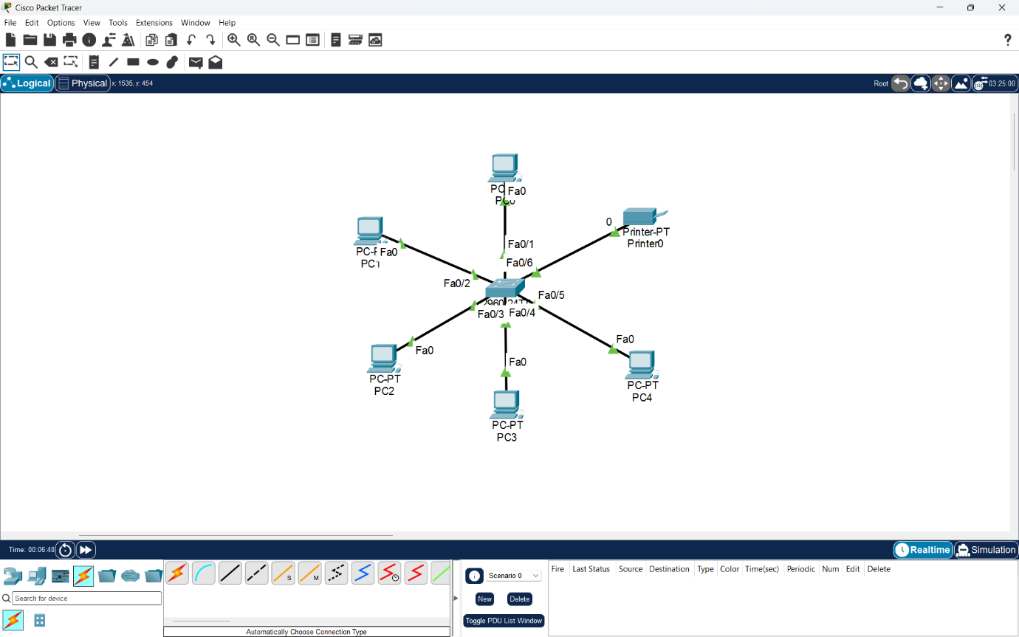

- Step 4: Assign IP Addresses

I used the Class C network 192.168.1.0/24.

Device | IP Address | Subnet Mask
- PC0 | 192.168.1.1 | 255.255.255.0
- PC1 | 192.168.1.2 | 255.255.255.0
- PC2 | 192.168.1.3 | 255.255.255.0
- PC3 | 192.168.1.4 | 255.255.255.0
- PC4 | 192.168.1.5 | 255.255.255.0
- Printer | 192.168.1.6 | 255.255.255.0

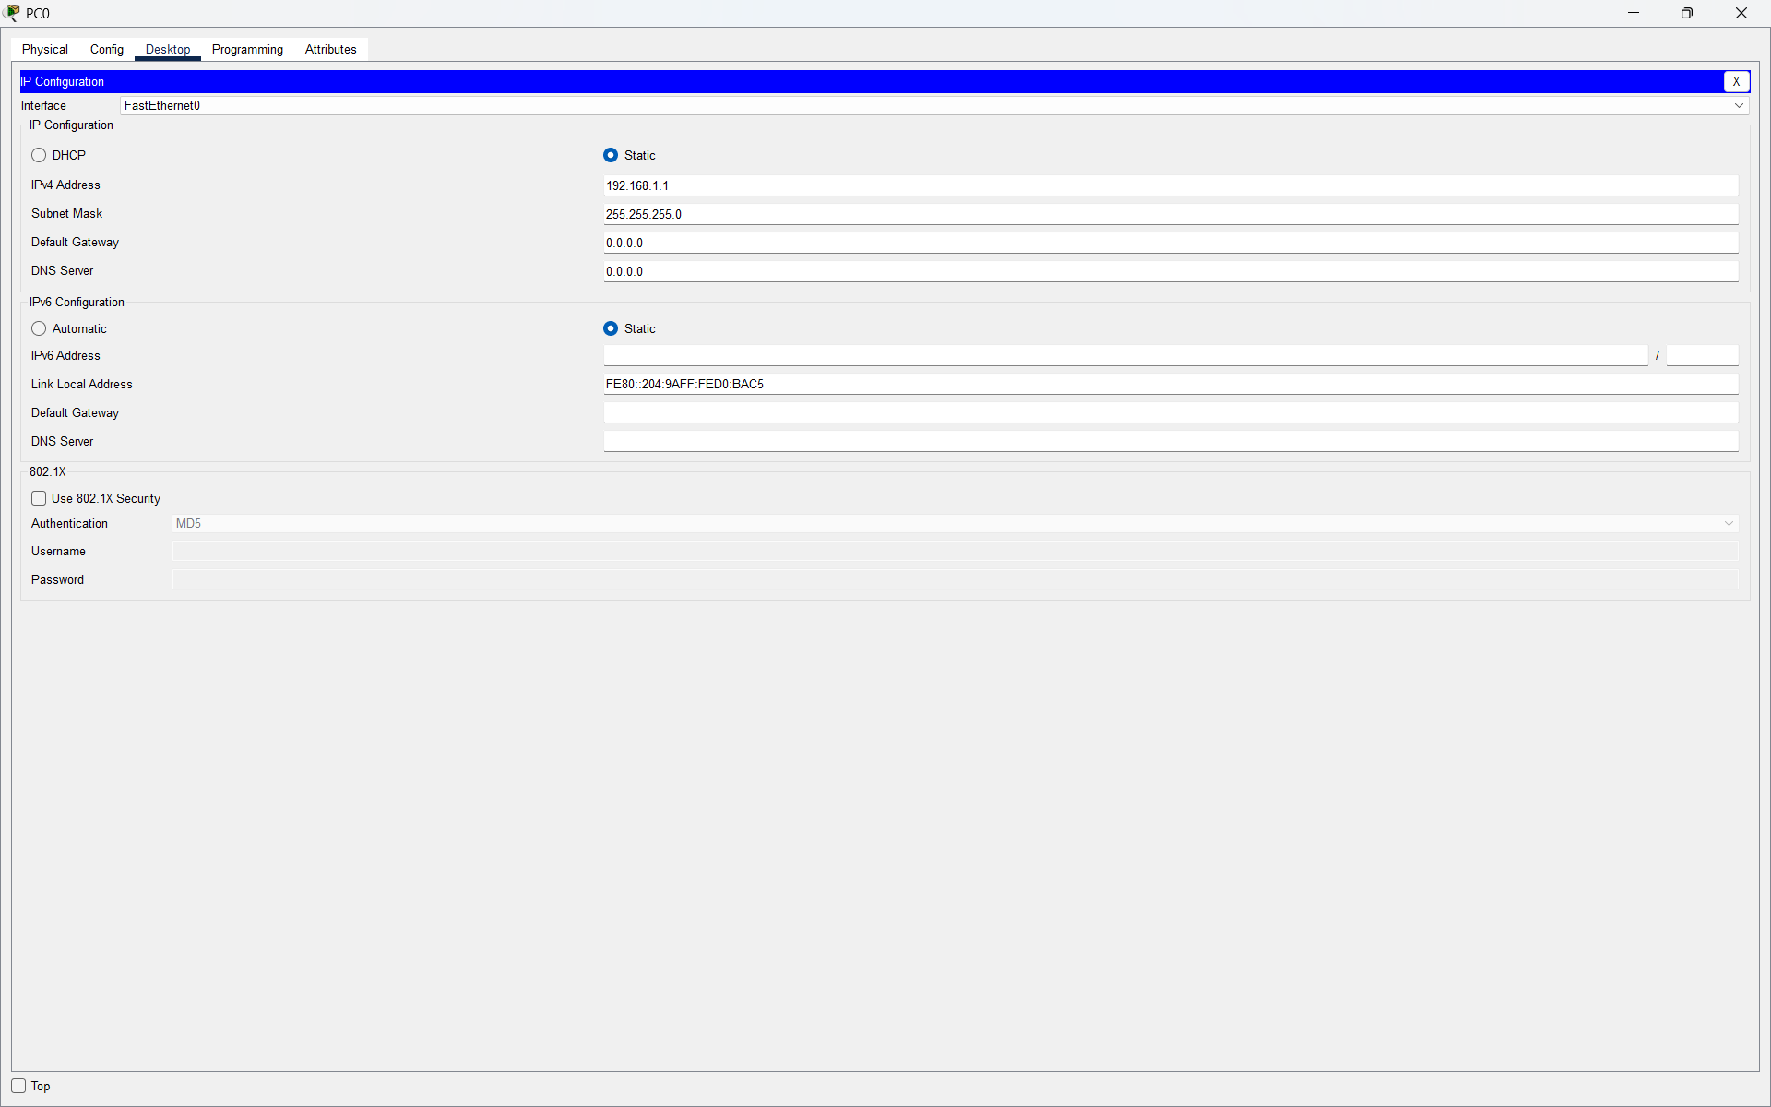
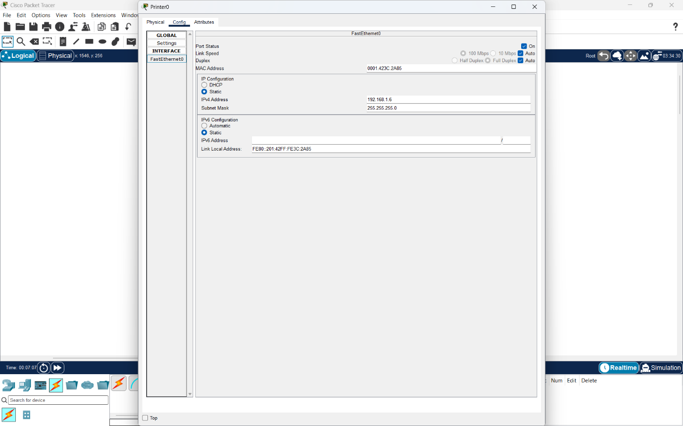

- Step 5: Test Connectivity
I opened Desktop → Command Prompt on one PC and used the ping command to check connectivity with the other devices.
For example:
- ping 192.168.1.3
- ping 192.168.1.6
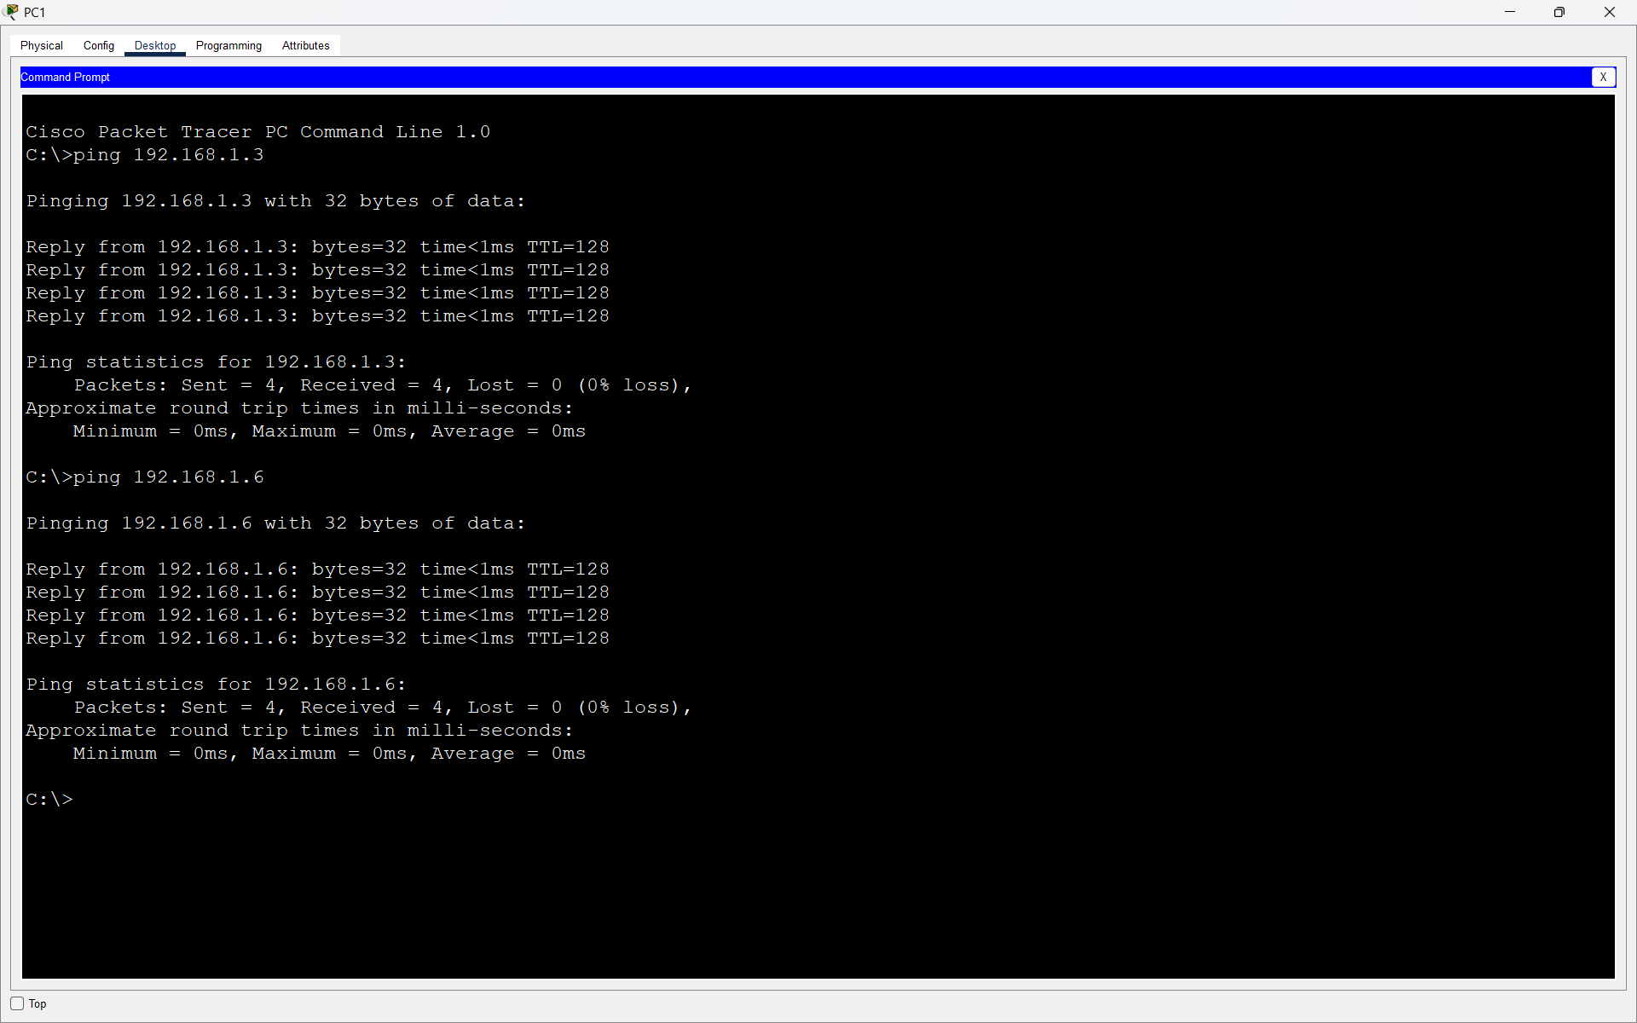
- Conclusion
The LAN topology was successfully created using 5 PCs, 1 network printer and a switch. All devices were assigned addresses from the 192.168.1.0/24 Class C network, and successful ping tests confirmed connectivity.

Task 4: Clean OS Installation

Answer
- Step 1: Created the Virtual Machine
I opened VirtualBox, created a new virtual machine and selected the Windows 11 ISO file for installation.
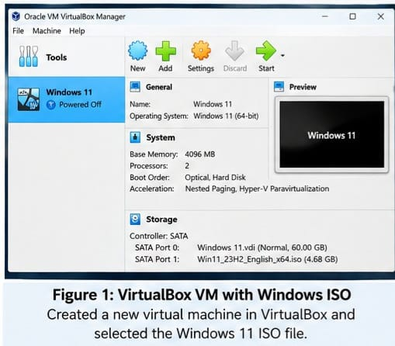
- Step 2: Started Windows Installation
I started the virtual machine and selected the required language and keyboard settings. Then I selected Install Windows 11.
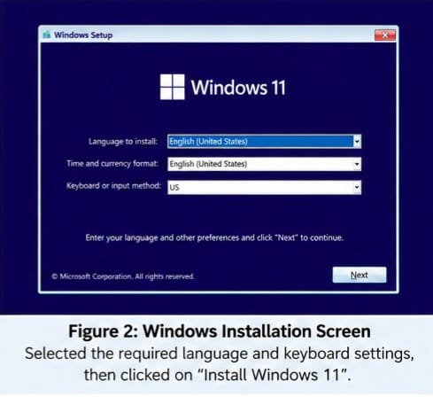
- Step 3: Selected Clean Installation
I selected the option to perform a clean/custom installation instead of upgrading an existing operating system.
- Step 4: Manually Partitioned the Disk
On the disk selection screen, I manually created the required partition instead of using automatic/guided partitioning. I then selected the created partition for Windows installation.

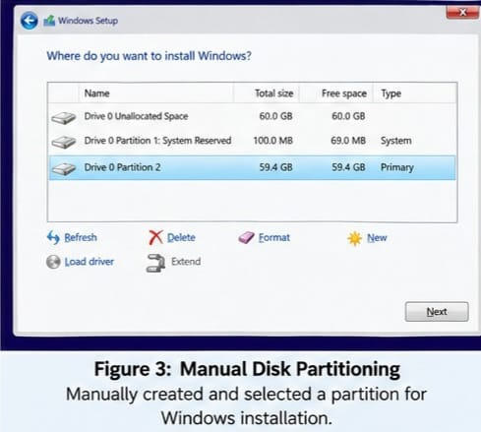

- Step 5: Installed Windows
Windows copied and installed the required files. After installation, the virtual machine restarted and Windows completed its initial setup.

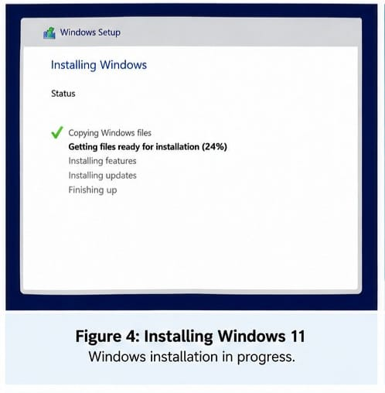
- Step 6: Optimized Startup Programs
I opened:
Task Manager → Startup apps
I checked the applications that automatically start with Windows and disabled unnecessary startup applications to improve boot performance.

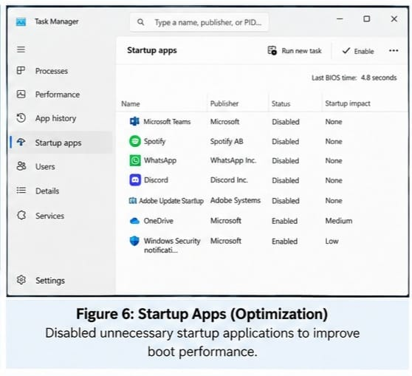
- Step 7: Verified Normal Boot
Finally, I restarted the virtual machine and confirmed that Windows booted normally without any errors.

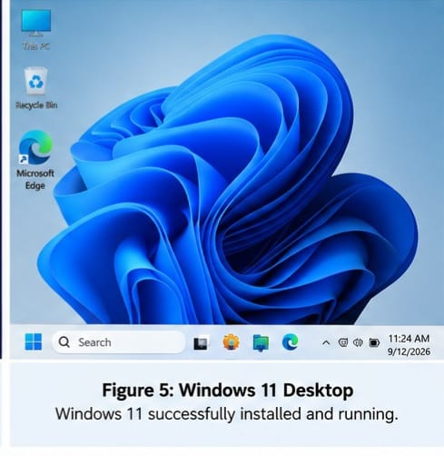
- Conclusion
I successfully performed a clean Windows installation with manual disk partitioning. I also disabled unnecessary startup applications to improve boot performance. After restarting, the operating system booted successfully without errors.

- Section C — Mini Capstone Project

Nexus Innovations — Diagnosing Random System Reboots

At Nexus Innovations, three rendering workstations successfully pass POST in the morning but restart randomly during heavy afternoon workloads. The computers are also kept inside poorly ventilated desk cabinets.
Q1. Three Hardware Components Most Likely to Cause Random Reboots?
Answer
The three main components I would check are:
1. CPU:
During heavy rendering work, CPU usage becomes high and produces more heat. If the CPU cooler is not working properly or airflow is poor, the CPU can overheat and cause the system to restart.
2. GPU:
Rendering can put a heavy load on the graphics card. A GPU can generate a lot of heat, especially inside a poorly ventilated cabinet.
3. PSU (Power Supply Unit):
During heavy workloads, the CPU and GPU require more power. If the PSU is weak, faulty, or unable to provide enough power, the computer may restart unexpectedly.
Q2. Why Does the System Pass POST in the Morning but Fail in the Afternoon?

Answer
- In the morning, the computers are cool and are not under a heavy workload, so they can pass POST normally.
- As employees use the systems for several hours and perform heavy rendering tasks, the CPU and GPU temperatures increase. Poor ventilation inside the desk cabinets makes it difficult for hot air to escape.
- Therefore, overheating or increased power demand under load can cause the computers to restart in the afternoon.
Q3. Using a Stress-Test Tool?

Answer
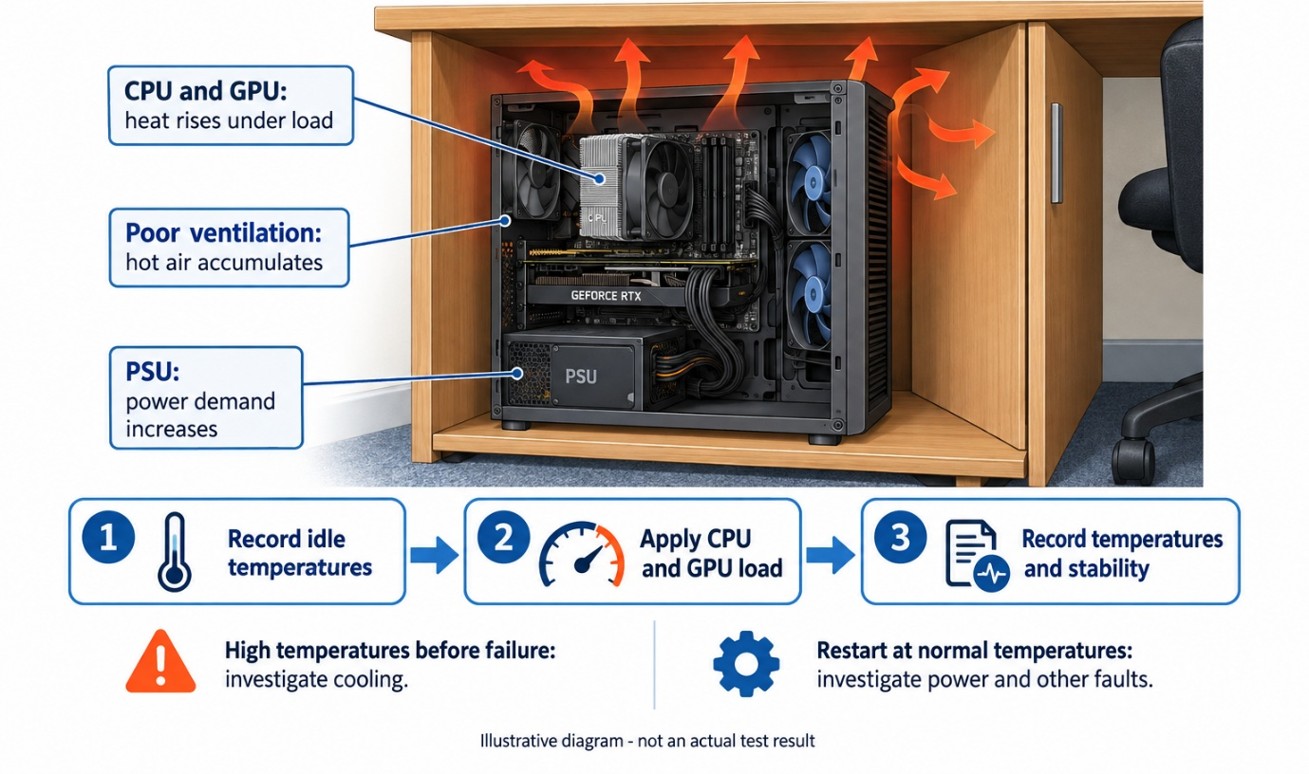
I would use a stress-test tool to put the CPU/GPU under a heavy load while monitoring the system.
After this paste in img
During the test, I would:
- Monitor the CPU and GPU temperatures.
- Check whether temperatures increase too much.
- Observe whether the computer restarts during the test.
- Check the system's stability under heavy load.
If the temperature becomes very high before the computer restarts, it indicates a possible thermal/overheating problem. If temperatures are normal but the PC still restarts under load, the PSU/power supply should also be checked.
Q4. Three Steps to Fix the Frequent Restarts?
Answer
- Step 1 – Improve Ventilation:
Move the computers out of poorly ventilated cabinets or provide enough space around them for proper airflow.
- Step 2 – Clean the Cooling System:
Clean dust from the CPU cooler, GPU fans, case fans and air vents. Also make sure all cooling fans are working correctly.
- Step 3 – Check Power Supply:
Check whether the PSU has enough capacity for the CPU, GPU and other components. A faulty or insufficient PSU should be replaced.
Q5. Is a PSU Upgrade Necessary?
Answer
A PSU upgrade is not automatically necessary.
- First, I would check the system temperatures and test the existing PSU. If the PSU provides enough power and works correctly, improving the cooling and ventilation may solve the problem.
- However, if testing shows that the PSU cannot provide enough stable power during heavy rendering workloads, then it should be replaced with a higher-capacity and good-quality PSU.

- Conclusion
The random restarts are most likely related to overheating or power problems during heavy workloads. Improving ventilation, cleaning the cooling system, monitoring temperatures and checking the PSU can help identify and solve the problem.

- Section D — AI-Augmented Learning

Q1. Step 1 — Build With AI?

Answer
Prompt:
Create an IP addressing and subnetting plan for Nexus Innovations startup office network. The network has 5 computer systems and 1 network printer. Specify the subnet, subnet mask, usable host range, and broadcast address. Assign an IP address to all 5 systems and 1 printer. Also identify some IP addresses that can be reserved for future expansion.

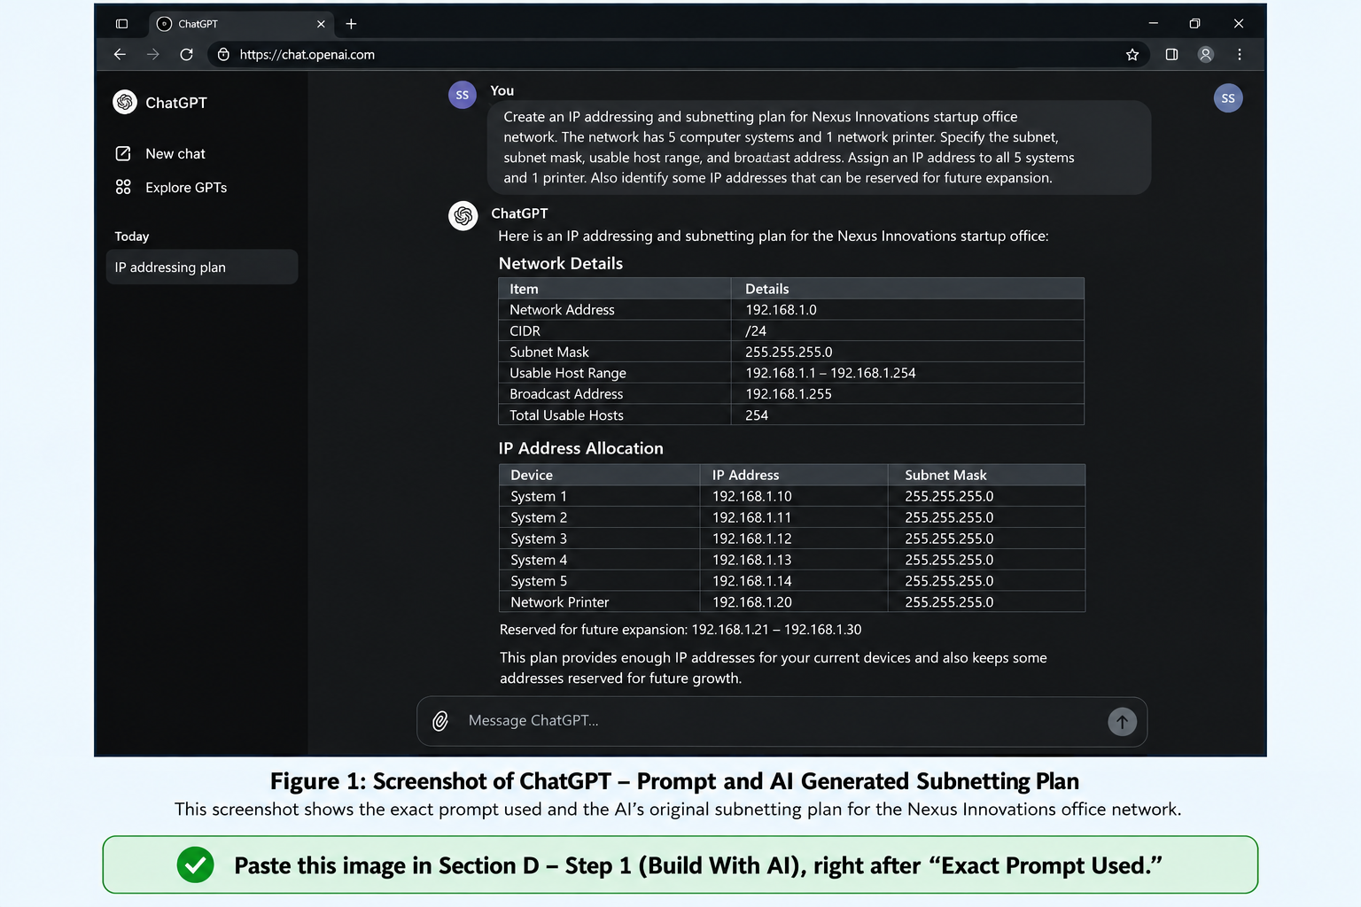

AI's Original Subnetting Plan
The AI suggested using the network 192.168.1.0/24.
- Network Information | Details
Network Address | 192.168.1.0
CIDR | /24
Subnet Mask | 255.255.255.0
Usable Host Range | 192.168.1.1 – 192.168.1.254
Broadcast Address | 192.168.1.255
Total Usable Hosts | 254

- Device IP Allocation
Device | IP Address | Subnet Mask
- System 1 | 192.168.1.10 | 255.255.255.0
- System 2 | 192.168.1.11 | 255.255.255.0
- System 3 | 192.168.1.12 | 255.255.255.0
- System 4 | 192.168.1.13 | 255.255.255.0
- System 5 | 192.168.1.14 | 255.255.255.0
- Network Printer | 192.168.1.20 | 255.255.255.0

- Reserved for future expansion:
192.168.1.21 – 192.168.1.30

Q2. Step 2 — Test & Debug Without AI?

Answer
I manually checked the AI-generated plan for overlapping IP addresses, network and broadcast addresses, host capacity, and space for future expansion, as required by the assessment.
The original /24 network works, but it provides 254 usable addresses, which is much more than required for only 6 current devices. Therefore, I changed the plan to a smaller /28 subnet.
- My Corrected Subnetting Plan
I selected:
192.168.1.0/28
A /28 gives 16 total addresses, of which 14 are usable host addresses.
Network Information |  | Corrected Details
- Network Address | 192.168.1.0
- CIDR | /28
- Subnet Mask | 255.255.255.240
- Usable Host Range | 192.168.1.1 – 192.168.1.14
- Broadcast Address | 192.168.1.15
- Total Usable Hosts | 14

- Corrected IP Address Allocation
Device | IP Address | Purpose
- System 1 | 192.168.1.1 | Computer
- System 2 | 192.168.1.2 | Computer
- System 3 | 192.168.1.3 | Computer
- System 4 | 192.168.1.4 | Computer
- System 5 | 192.168.1.5 | Computer
- Network Printer | 192.168.1.6 | Printer
- Reserved | 192.168.1.7 – 192.168.1.14 | Future expansion

Network address: 192.168.1.0 — cannot be assigned to a device.
Broadcast address: 192.168.1.15 — cannot be assigned to a device.

- Verification
I manually verified the corrected subnet:/28 = 255.255.255.240
Number of addresses: 256 − 240 = 16 addresses
Therefore:
Network: 192.168.1.0
First usable: 192.168.1.1
Last usable: 192.168.1.14
Broadcast: 192.168.1.15
There are 14 usable IP addresses, so 6 can be used for the current devices and the remaining 8 addresses can be reserved for future expansion.

- 3–4 Line Note — What I Changed and Why
The AI originally suggested a /24 subnet, which provides 254 usable host addresses. This was much larger than required for only 5 systems and 1 printer. I changed the network to a /28 subnet, which provides 14 usable addresses. Six addresses are used for the current devices and eight are kept available for future expansion.

- Final Conclusion
The corrected 192.168.1.0/28 subnet is sufficient for the Nexus Innovations office. It provides enough addresses for all 5 systems and 1 printer while also leaving space for future devices. I also verified that there are no overlapping IP addresses and that the network and broadcast addresses are not assigned to any device.

